THE CORRELATION BETWEEN STUDENTS’ MOTIVATION AND THEIR PERCEPTION ON THE COMMUNITY OF INQUIRY (COI) IN AN ONLINE ENGLISH COURSE

THESIS

Submitted in partial fulfilment of the requirements for the Degree of Master of English Language Education

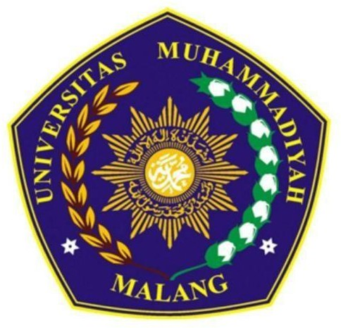

By

Mifta Libby Askangela 202110560211002

DIRECTORATE OF POSTGRADUATE PROGRAM UNIVERSITAS MUHAMMADIYAH MALANG

2022



THE CORRELATION BETWEEN STUDENTS’ MOTIVATION AND THEIR PERCEPTION ON THE COMMUNITY OF INQUIRY (COI) IN AN ONLINE ENGLISH COURSE

by

# MIFTA LIBBY ASKANGELA 202110560211002

Accepted on Thursday, 27th October 2022

Advisor I Advisor II

Dr. Estu Widodo Ria Arista A., Ph.D

Director of the Head of Department

Postgraduate Program

Prof. Akhsanul In’am, Ph.D Dr. Estu Widodo



**T H E S I S**

Written by:

# MIFTA LIBBY ASKANGELA 202110560211002

Examined in front of the examiners

on **Monday, 27th October 2022** and it was decided that it fulfilled the requirements to get

the Degree of Master of English Language Education

at the Postgraduate Program of Universitas Muhammadiyah Malang

The Examiners

Chief : Dr. Estu Widodo Secretary : Ria Arista A., Ph.D

1st Examiner : Prof. Dwi Poedjiastuti, MA, Ph.D 2nd Examiner : Dr. Masduki, M.Pd